Pistol Grip Infrared Thermometers
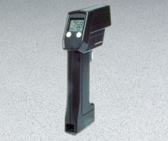 | Pistol-Grip Infrared Thermometer  Code: 88-4400  Attributes: Resolution µs = 0.1, Description = Pistol-Grip Infrared Thermometer  Standards:

