Submersible Load Transducers
 | Distance Piece Stainless Steel for Use with Submerisble Load Cells and Axial Strain Transducers.  Code: 27-1293  Attributes: Description = Distance piece stainless steel for use with submersible load cells, Load device type = Stainless Steel distance piece for use with submersible loads cells, Weight, lbs = 1  Standards:

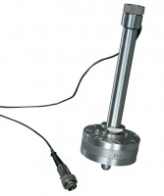 | Submersible Load Transducer Assembly 5kN Capacity In Compression.  Code: 27-1573  Attributes: Load device type = Submersible, Force Capacity, kN = 5, Description = Submersible load transducer, Weight, lbs = 2.25  Standards:

