Compression Machine Upgrades
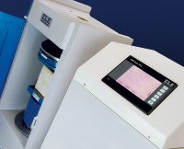 | Console Assy ADR-Auto V2.0  Code: 37-4880/01  Attributes: Description = To upgrade an existing "AutoTest" to ADR Auto V2.0  Standards:

 | ADR Touch Head Kit to upgrade manual compression machines  Code: 37-4990/09  Attributes: Description = To upgrade existing ADR machines to ADR Touch  Standards:

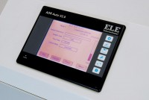 | Kit to Upgrade ADR-Auto Compression m/c to V2.0  Code: 37-4900/01  Attributes: Description = To upgrade ADR-Auto machines to ADR Auto V2.0  Standards:

