Basic 4" Marshall Stability Test Set with Manual Compaction
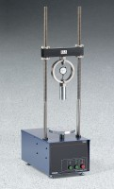 | Basic 4" Marshall Stability Test Set with Manual Compaction  Code: 5002/02  Attributes: Rated Power = 110vAC, 60Hz, 1ø., Description = Basic 4″ Marshall Stability Test Set with Manual Compaction  Standards: ASTM D6926, ASTM D6927, AASHTO T245

