Cube Moulds
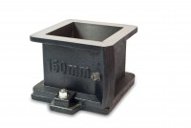 | 100mm Cube Mould 2-Part Clamp Type. Cast Iron Construction. BS EN Compliant.  Code: 34-4650  Attributes: Cube mould type = 2 part, Specimen Size = 100 x 100 mm  Standards:

150mm Cube Mould 2-Part Clamp Type. Cast Iron Construction. BS EN Compliant.
Code: 34-4670
Attributes: Cube mould type = 2 part, Specimen Size = 150 x 150 mm
Standards:

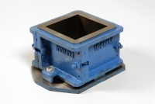 | 100mm Cube Mould 4-Part Clamp Type. Cast Iron Construction. BS EN Compliant.  Code: 34-4520  Attributes: Cube mould type = 4 part, Specimen Size = 100 x 100 mm, Internal Dimensions dia x h, ” = 100 x 100 x 100  Standards:

150mm Cube Mould 4-Part Clamp Type. Cast Iron Construction. BS EN Compliant.
Code: 34-4570
Attributes: Specimen Size = 150 x 150 mm, Cube mould type = 4 part, Internal Dimensions dia x h, ” = 150 x 150 x 150
Standards:

200mm Cube Mould Clamp Type. Cast Iron Construction. Stamped Mould Sections. EN Compliant.
Code: 34-4620
Attributes: Cube mould type = 4 part, Specimen Size = 200 x 200 mm, Weight, kg = 35
Standards:

