Heavy-Duty Cylinder Moulds
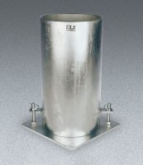 | Heavy-Duty Cylinder Mould 4" x 8"  Code: 34-5282  Attributes: Optimum Pouring Range, °F = 260 - 290, Description = Heavy-Duty Cylinder Mould 4″ x 8″  Standards: ASTM C39, ASTM C192, AASHTO T23, ASTM T126

Heavy-Duty Cylinder Mould 6" x 12"
Code: 34-5280
Attributes: Optimum Pouring Range, °F = 260 - 290, Description = Heavy-Duty Cylinder Mould 6″ x 12″
Standards: ASTM C39, ASTM C192, AASHTO T23, ASTM T126

