Axial Displacement
 | Dial Gauge 25mm Travel X 0.01mm Divisions  Code: 25-4210  Attributes: Description = Dial gauge 25mm travel x 0.01mm divisions, Dial Indicator = 25 mm Range  Standards: BS 1377

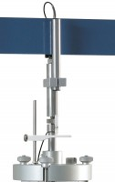 | Axial Strain Transducer Assembly 50mm Travel Fitted with 5 Pin Din Plug.  Code: 27-1617  Attributes: Description = Axial strain transducer assembly 50mm travel, Mounting Bracket = Included as standard.  Standards:

