Permeability of Rock
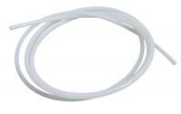 | Nylon Tubing 6mm Od 3500Kpa.  Code: 26-1926  Attributes: Description = Nylon tubing  Standards:

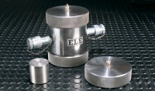 | Pair of Permeability End Caps Nx. Supplied with Distance Block.  Code: 70-1750  Attributes: Description = Permeability End Caps, Weight, kg = 6.2 kg  Standards:

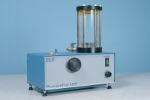 | Pressure Test 3500 Oil/Water Constant Pressure System with Digital Pressure Gauge.  Code: 70-5130/01  Attributes: Description = Pressure Test 3500 Oil/Water Constant Pressure System, Power Supply = 220 - 240 V AC, 50 - 60 Hz, 1 ph  Standards:

