Le Chatelier Flask
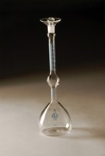 | Le Chatelier Flask  Code: 38-1200  Attributes: Description = Le Chatelier Flask, Weight, oz. = 8  Standards: EN 196-6, ASTM C128, ASTM C188, E 694, AASHTO T133

