High pressure application consolidation cells and accessories
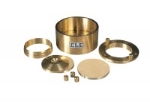 | Consolidation Cell Complete 50mm Diameter Sample.  Code: 25-0455  Attributes: Description = Consolidation cell 50 mm, Sample diameter = 50 mm, Stress for 1 kg, kPa = 50  Standards:

50mm Dia Upper and Lower Porous Stones for Use on EL25-0455 Series Cell.
Code: 25-0455/13
Attributes: Description = Upper and lower porous stones, Sample diameter = 50 mm, Weight, lbs = 0.35
Standards:

Cutting Ring 50mm Cell.
Code: 25-0458
Attributes: Description = Cutting ring, Sample diameter = 50 mm, Weight, lbs = 1.1
Standards:

 | Calibration Disc 50mm Cell  Code: 25-0461  Attributes: Description = Calibration disc, Sample diameter = 50 mm, Weight, lbs = 0.642  Standards:

