Manual Compaction
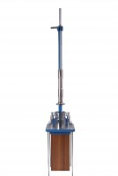 | Compaction Hammer  Code: 45-6460  Attributes: Description = Compaction Hammer, Drop, ” = 18  Standards: EN 12697-30, ASTM D6926, AASHTO T245

Compaction Pedestal BS 598
Code: 45-6410
Attributes: Description = Compaction Pedestal, Weight, kg = 40
Standards: EN 12697-30

