Accu-Tek 250 Series Flexure Attachments
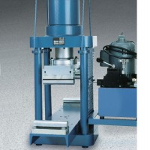 | Flexural Attachment  Code: 37-5528  Attributes: Description = Flexural Attachment - 79 kg, Upper Head = Fastens to upper platen by 4 spools.  Standards: ASTM C78, ASTM C293, AASHTO T97

