S-Type Load Cell
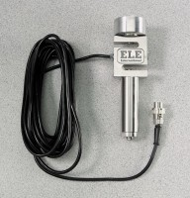 | S-Type Load Cell 500 lb Capacity  Code: 27-1581  Attributes: Mounting Hardware = Includes all necessary hardware for mounting to the<br>Tritest 50 and Versa-Loader load frames., Description = S-Type Load Cell 500 lb Capacity  Standards:

S-Type Load Cell 2,000 lb Capacity
Code: 27-1583
Attributes: Mounting Hardware = Includes all necessary hardware for mounting to the<br>Tritest 50 and Versa-Loader load frames., Description = S-Type Load Cell 2,000 lb Capacity
Standards:

S-Type Load Cell 10,000 lb Capacity
Code: 27-1587
Attributes: Mounting Hardware = Includes all necessary hardware for mounting to the<br>Tritest 50 and Versa-Loader load frames., Description = S-Type Load Cell 10,000 lb Capacity
Standards:

