Hveem Stabilometer
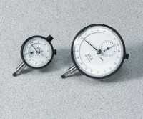 | Dial Indicator - 1.0" Range  Code: 88-4100  Attributes: Description = Mechanical Dial Indicator - 1.0" Range, Dial Indicator = 1.0" Range  Standards:

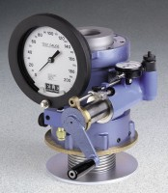 | Hveem Stabilometer - ASTM Type  Code: 45-7500  Attributes: Followers = Two included; one 3.985” ± 0.005” diam.<br>x 5-1/2”; one 3.95” ± 0.005” diam. x 5” h., Description = Hveem Stabilometer - ASTM Type  Standards: ASTM D1560, ASTM D2844, AASHTO T190, AASHTO T246

 | Hveem Stabilometer - California Type  Code: 45-7505  Attributes: Followers = Two included; one 3.985” ± 0.005” diam.<br>x 5-1/2”; one 3.95” ± 0.005” diam. x 5” h., Description = Hveem Stabilometer - California Type  Standards: CA 301, CA 366

Hveem Stabilometer - Texas Type
Code: 45-7510
Attributes: Followers = Two included; one 3.985” ± 0.005” diam.<br>x 5-1/2”; one 3.95” ± 0.005” diam. x 5” h., Description = Hveem Stabilometer - Texas Type
Standards:

R-Value Rough Hveem Test Mold
Code: 45-7505/10
Attributes: Description = R-Value Rough Hveem Test Mold
Standards:

S-Value Smooth Hveem Test Mold
Code: 45-7505/12
Attributes: Description = S-Value Smooth Hveem Test Mold
Standards:

Diaphragms
Code: 45-7500/12
Attributes: Description = Diaphragms
Standards:

Hveem Diaphragm Replacement Tool
Code: 45-7520
Attributes: Description = Hveem Diaphragm Replacement Tool
Standards:

Hveem Test Block
Code: 45-7500/10
Attributes: Description = Hveem Test Block
Standards:

