Corrosion Mapping System
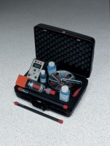 | Corrosion Mapping System  Code: 35-2165  Attributes: Memory Capacity = 15 ,866 half-cell readings; 12 8 max.<br>scans., Description = Corrosion Mapping System  Standards: ASTM C876

