Vapor Emission Test Kit
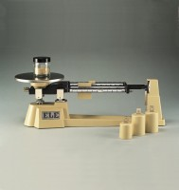 | Triple Beam Balance  Code: 78-7140  Attributes: Description = Triple Beam Balance, Weight, lbs = 8  Standards:

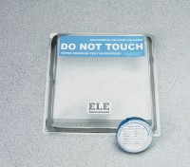 | Vapor Emission Test Kit  Code: 35-3968  Attributes: Dome = Clear plastic with butyl rubber gasket., Description = Vapor Emission Test Kit  Standards: ASTM E1907, F 1869

