Concrete Micrometer
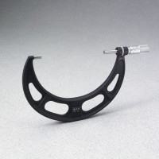 | Concrete Micrometer  Code: 34-5305  Attributes: Range, ” = 5-1/2” to 6-1/2”, 6” position at sleeves center., Description = Concrete Micrometer  Standards:

