Cone Penetrometer Method
 | Cone Penetrometer. Complete with Stainless Steel Test Cone.  Code: 24-0540  Attributes: Description = Cone Penetrometer, Cone Relase = Manual  Standards: BS 1377, EN 1997-2

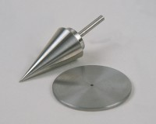 | Penetration Test Cone  Code: 24-0544  Attributes: Description = Test cone, Cone = 1 x 30°, 35 mm cone  Standards:

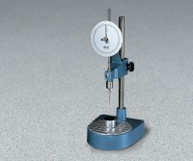 | Test Gauge for Checking Condition of Cone Point.  Code: 24-0546  Attributes: Description = Test gauge, Dimensions w x d x h, ” = 28x45x14 mm  Standards:

Penetration Test Cup.
Code: 24-0548
Attributes: Description = Penetration test cup, Dimensions, diameter x length, ” = 55x40
Standards:

