Laboratory Vibrator
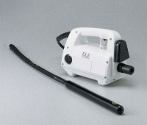 | Laboratory Vibrator  Code: 34-6430/02  Attributes: Speed = 10,000, Description = Laboratory Vibrator  Standards:

