Trowels and Floats
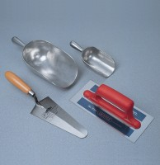 | Trowel - Gardeners type  Code: 81-0310  Attributes: Description = Trowel - Gardener's type  Standards:

Trowel - Gauging
Code: 81-0335
Attributes: Description = Trowel - Gauging
Standards:

Float - Plasterer’s type
Code: 81-0340
Attributes: Description = Float, Weight, kg = 0.45
Standards:

