Specific Gravity (Rice) Test with 6,000 gram Vacuum Pyknometer
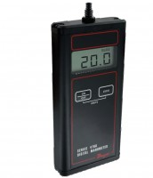 | Residual Pressure Manometer  Code: 45-9330  Attributes: Description = Residual Pressure Manometer  Standards: ASTM D2041, EHS 9300, AASHTO T209, AASHTO T283

 | Rice Test Vibrator 115vAC, 50/60 Hz  Code: 45-9315/02  Attributes: Description = Rice Test Vibrator 115 V AC 50/60 Hz, Dimensions, h x dia, ” = 19-1/2 x 12  Standards: ASTM D2041, AASHTO T209

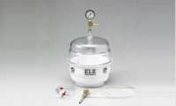 | Vacuum Pyknometer, 6000 g  Code: 45-9300  Attributes: Description = Vacuum Pyknometer (6,000 gram)  Standards: EN 12697-5, ASTM D2041, AASHTO T209, AASHTO T283

Attachment Required for 6000 g
Code: 45-9315/10
Attributes: Description = Attachment required for Rice Test Vibrator
Standards: EN 12697-5

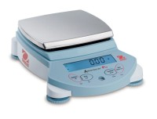 | High Capacity Electronic Balance  Code: 88-1094/02  Attributes: Description = High Capacity Electronic Balance  Standards:

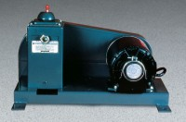 | Standard Vacuum Pump  Code: 88-3100/02  Attributes: Description = Standard Vacuum Pump  Standards:

Filtering Kit
Code: 45-9301
Attributes: Description = Filtering Kit
Standards:

