Soundness of Portland Cement by the Autoclave Method
 | Lid Sealing Gasket  Code: 38-3800/13  Attributes: Description = Lid Sealing Gasket  Standards: ASTM C151

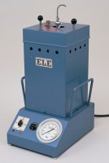 | Autoclave  Code: 38-3800/01  Attributes: Description = Autoclave, Power Supply = 220 - 240 V AC, 50 - 60 Hz, 1 ph  Standards: ASTM C151

