Rapid method by Speedy Moisture Tester
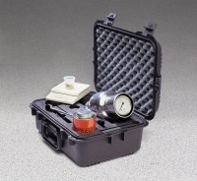 | Speedy Moisture Tester D2 Large 0-20% Moisture Range. Supplied Less Calcium Carbide  Code: 23-7452  Attributes: Model/type = D2 Large, Moisture range % = 0 to 20, Gauge divisions % = 0.2, Sample weight g = 20, Dimensions w x d x h, ” = 518x382x212 mm, Description = Speedy Moisture Tester  Standards: BS 812, ASTM D4944, AASHTO T217

Speedy Moisture Tester G2 Large 0-50% Moisture Range. Supplied Less Calcium Carbide
Code: 23-7462
Attributes: Model/type = G2 Large, Moisture range % = 0 to 50, Gauge divisions % = 0.5, Sample weight g = 8
Standards: ASTM D4944, AASHTO T217

Speedy Moisture Tester D2 Small 0-20% Moisture Range. Supplied Less Calcium Carbide
Code: 23-7502
Attributes: Model/type = D2 Small, Moisture range % = 0 to 20, Gauge divisions % = 0.2, Sample weight g = 6
Standards: ASTM D4944, AASHTO T217

