Ring and Ball Apparatus
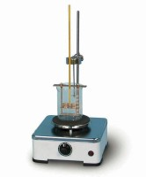 | BS/EN Ring and Ball Apparatus  Code: 46-4605  Attributes: Description = BS/EN Ring and Ball Apparatus, Weight, kg = 0.56  Standards: EN 1427, BS 2000-58

 | Magnetic Stirrer  Code: 46-4825/01  Attributes: Description = Magnetic Stirrer, Power Supply = 220 - 240 V AC, 50 - 60 Hz, 1 ph  Standards: EN 1427, BS 2000-58

Thermometer
Code: 82-5272
Attributes: Description = Thermometer - 76 mm immersion, Temperature Range °C = -10 to +210
Standards: EN 1427, BS 2000-58

Thermometer
Code: 82-5274
Attributes: Temperature Range °C = -10 to +210, Description = Thermometer - Total Immersion
Standards: EN 1427, BS 2000-58

