Chloride Content: Rapid Method
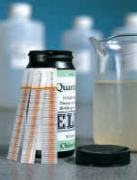 | Quantab Chloride Titrator Type 1175 Titration Range 0.005% - 0.1% 30-600ppm Nacl Pack of 40 Strips.  Code: 42-2950  Attributes: Range ppm = 30 - 600, Weight, kg = 0.01  Standards:

Quantab Chloride Titrator Strips Type 1176 Titration Range 0.05%-1% (300-6000 ppm) Nacl Pack of 40.
Code: 42-2952
Attributes: Range ppm = 300 - 6000, Weight, kg = 0.01
Standards:

