Falling Head Apparatus
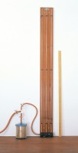 | Falling Head Permeability Cell.  Code: 25-0605  Attributes: Description = Falling head permeability cell, Top Plate, ” = Machined  Standards:

