Digital Tritest 50 Load Frame
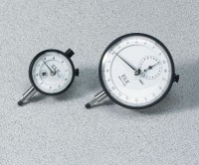 | Dial Indicator - 1.0" Range  Code: 88-4100  Attributes: Description = Mechanical Dial Indicator - 1.0" Range, Dial Indicator = 1.0" Range  Standards:

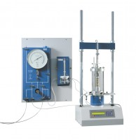 | Digital Tritest 50  Code: 25-3518/01  Attributes: Description = Digital Tritest 50 Load Frame 220-240 V AC, CBR Penetration = Yes, Unconfined Compression = Yes, Unconfined Compression = Yes, Consolidated Undrained = Yes, Consolidated Drained = Yes, Capacity, lbf = 11,200  Standards: BS 1377-7, BS 1377-8, BS 1924-2, ASTM D1883, ASTM D2166, ASTM D2850, ASTM D4767, ASTM D7181, AASHTO T99, AASHTO T134, AASHTO T135, AASHTO T136, AASHTO T180, AASHTO T193, AASHTO T208, AASHTO T296, AASHTO T297

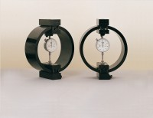 | 50kN Load Measuring Ring  Code: 78-0860  Attributes: Description = Load ring - 50 kN, Value of CBR % = Above 40%, Overall Height, mm = 248, Force Capacity, kN = 50, Load device type = Load ring  Standards: EN 12697-34

Clamped Boss Load Ring - 28.0 kN
Code: 78-0760
Attributes: Description = Load ring - 28 kN, Load device type = Load ring, Force Capacity, kN = 28, Value of CBR % = Average range of CBR, Overall Height, mm = 248
Standards:

Clamped Boss Load Ring - 10.0 kN
Code: 78-0460
Attributes: Description = Load ring - 10 kN, Value of CBR % = 8% to 40%, Weight, lbs = 10.54, Force Capacity, kN = 10
Standards:

Clamped Boss Load Ring - 4.5 kN
Code: 78-0260
Attributes: Description = Load ring - 4.5 kN, Load device type = Load ring, Force Capacity, kN = 4.5, Weight, lbs = 9.25
Standards:

Clamped Boss Load Ring - 3.0 kN
Code: 78-0160
Attributes: Description = Load ring - 3 kN, Force Capacity, kN = 3, Weight, lbs = 9.25
Standards: BS 1377, ASTM D3080

Clamped Boss Load Ring - 2.0 kN
Code: 78-0060
Attributes: Description = Load ring - 2 kN, Force Capacity, kN = 2, Value of CBR % = Up to 8%, Capacity, lbf = 450, Capacity kN = 2.0
Standards: BS 1377, ASTM D3080

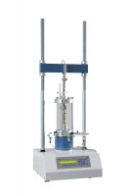 | Digital Tritest 50 Load Frame 110-120vAC  Code: 25-3518/02  Attributes: Capacity, lbf = 11,200, Description = Digital Tritest 50 Load Frame 110-120vAC  Standards: ASTM D1883, ASTM D2166, ASTM D2850, ASTM D4767, ASTM D7181, AASHTO T99, AASHTO T134, AASHTO T135, AASHTO T136, AASHTO T180, AASHTO T193, AASHTO T208, AASHTO T296, AASHTO T297

 | Electronic Digital Indicator, 1.0"/25.4 mm range  Code: 88-4220  Attributes: Scale Divisions, tons/sq. Ft. = 0.0001" (0.002 mm), Description = Electronic Digital Indicator, 1.0″/25.4 mm range  Standards:

Dial Gauge 25mm Travel X 0.01mm Divisions
Code: 25-4210
Attributes: Description = Dial gauge 25mm travel x 0.01mm divisions, Dial Indicator = 25 mm Range
Standards: BS 1377

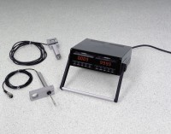 | 2 Channel Digital Readout, English  Code: 27-1108/01  Attributes: Rated Power = 220vAC, 50/60Hz, 1ø., Description = 2 Channel Digital Readout, English  Standards:

2 Channel Digital Readout, English
Code: 27-1108/02
Attributes: Rated Power = 110vAC, 50/60Hz, 1ø., Description = 2 Channel Digital Readout, English
Standards:

2 Channel Digital Readout, Metric
Code: 27-1109/02
Attributes: Rated Power = 110vAC, 50/60Hz, 1ø., Description = 2 Channel Digital Readout, Metric
Standards:

