Laboratory Sieve Shaker
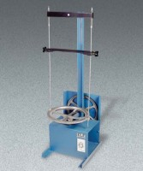 | Laboratory Sieve Shaker 110V 60 Hz  Code: 80-0455/02  Attributes: Description = Economy Sieve Shaker 110V 60 Hz  Standards:

