Compaction Permeameter
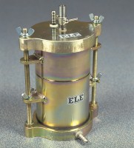 | Compaction Permeameter.  Code: 25-0607  Attributes: Description = Compaction permeameter, Porous Stones = 101.6 x 12.7  Standards:

 | Standpipe Panel.  Code: 25-0609  Attributes: Description = Standpipe panel  Standards:

De-Airing Tank.
Code: 25-0611
Attributes: Description = De-airing tank, Weight, kg = 2.9
Standards:

Soaking Tank.
Code: 25-0613
Attributes: Description = Soaking tank, Weight, kg = 4.2
Standards:

