Acme Laboratory Penetrometer
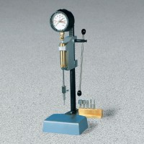 | Acme Laboratory Penetrometer  Code: 38-2670  Attributes: Needles = 6 included; 1/40, 1/20, 1/10, 1/4, 1/2 and 1 sq. in. end areas; stored in wooden block holder., Description = Acme Laboratory Penetrometer  Standards: ASTM C-403, AASHTO T197

