Tripod Attachment
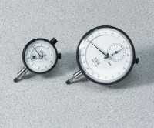 | Mechanical Dial Indicator - 25 mm Range Clockwise Movement  Code: 88-4110  Attributes: Dial Indicator = 25 mm Range, Description = Mechanical Dial Indicator - 25 mm Range Clockwise Movement  Standards:

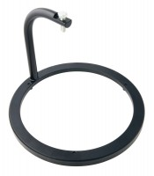 | Swell Tripod  Code: 24-9262  Attributes: Description = Swell tripod, Clamp = Integral part of assembly; holds dial indicator.  Standards: ASTM D1883, AASHTO T193

Dial Indicator - 1.0" Range
Code: 88-4100
Attributes: Description = Mechanical Dial Indicator - 1.0" Range, Dial Indicator = 1.0" Range
Standards:

 | Electronic Digital Indicator, 1.0"/25.4 mm range  Code: 88-4220  Attributes: Scale Divisions, tons/sq. Ft. = 0.0001" (0.002 mm), Description = Electronic Digital Indicator, 1.0″/25.4 mm range  Standards:

