Aggregate Impact Value (AIV)
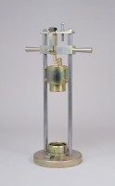 | Aggregate Impact Value Apparatus Complete with 16mm Dia X 600mm Long Rod  Code: 42-4000  Attributes: Description = Aggregate Impact Value Apparatus, Main body length, arm, operating length mm = 75 x 50, 16 x 600  Standards: BS 812-112

