Portable Dynamic Cone Penetrometer/Auger Set
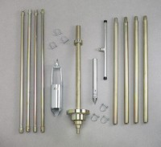 | Portable Dynamic Cone Penetrometer  Code: 29-5505  Attributes: Penetrometer Cone = 30°., Description = Portable Dynamic Cone Penetrometer  Standards:

Portable Dynamic Cone Penetrometer/Auger Set
Code: 29-5500
Attributes: Penetrometer Cone = 30°., Description = Portable Dynamic Cone Penetrometer/Auger Set
Standards:

 | 3" Drive Tube Assembly  Code: 29-5510  Attributes: Weight, lbs = 11.93346, Description = 3″ Drive Tube Assembly  Standards:

3" Sample Tube
Code: 29-5510/10
Attributes: Dimensions w x d x h, ” = 76x76x250 mm, Description = 3″ Sample Tube
Standards:

3" Plastic End Cap
Code: 29-5510/11
Attributes: Diameter, ” = 3, Description = 3″ Plastic End Cap
Standards:

Sliding Drive Hammer Assembly
Code: 29-5500/10
Attributes: Dimensions w x d x h, ” = 216x213x930 mm, Description = Sliding Drive Hammer Assembly
Standards:

Cone Penetrometer Point
Code: 29-5500/11
Attributes: Weight, lbs = 3.2, Description = Cone Penetrometer Point
Standards:

30" Drill Rod with Extensions
Code: 29-5500/12
Attributes: Dimensions w x d x h, ” = 30x30x838 mm, Description = 30″ Drill Rod with Extensions
Standards:

3-1/4" Auger Head
Code: 23-1400/10
Attributes: Weight, lbs = 3.52, Description = 3-1/4″ Auger Head
Standards:

Tee Handle
Code: 23-1400/11
Attributes: Weight, lbs = 2.03, Description = Tee Handle
Standards:

Auger Extensions 36"
Code: 23-1400/12
Attributes: Weight, lbs = 2.34, Description = Auger Extensions 36″
Standards:

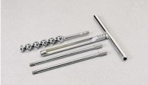 | Connector Pin  Code: 23-1400/13  Attributes: Weight, lbs = 0.22, Description = Connector Pin  Standards:

