Testing Anvil
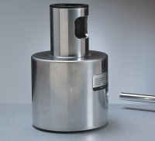 | Testing Anvil  Code: 35-1530  Attributes: Description = Testing Anvil, Weight, lbs = 37.06  Standards: ASTM C805

