6" Cylinder Capper
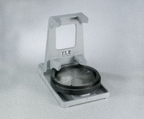 | 6" Cylinder Capper  Code: 34-6093  Attributes: Guide Ring = Tapers to 6-1/8” (155 mm) diam. clearance;<br>removable., Description = 6″ Cylinder Capper  Standards: ASTM C617, AASHTO T231

