CBR Loading Press, Hand-Operated
 | Digital Proving Ring, 6,000 lbs (28.0 kN)  Code: 78-0764  Attributes: Overall Height, mm = 248, Description = Digital Proving Ring, 6,000 lbs (28.0 kN)  Standards:

Digital Proving Ring, 11,200 lbs (50.0 kN)
Code: 78-0864
Attributes: Overall Height, mm = 248, Description = Digital Proving Ring, 11,200 lbs (50.0 kN)
Standards:

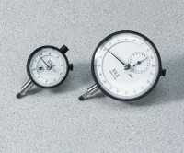 | Mechanical Dial Indicator - 25 mm Range Clockwise Movement  Code: 88-4110  Attributes: Dial Indicator = 25 mm Range, Description = Mechanical Dial Indicator - 25 mm Range Clockwise Movement  Standards:

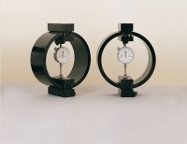 | 50kN Load Measuring Ring  Code: 78-0860  Attributes: Description = Load ring - 50 kN, Value of CBR % = Above 40%, Overall Height, mm = 248, Force Capacity, kN = 50, Load device type = Load ring  Standards: EN 12697-34

Clamped Boss Load Ring - 28.0 kN
Code: 78-0760
Attributes: Description = Load ring - 28 kN, Load device type = Load ring, Force Capacity, kN = 28, Value of CBR % = Average range of CBR, Overall Height, mm = 248
Standards:

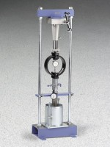 | CBR Loading Press, Hand-Operated  Code: 24-9345  Attributes: Description = CBR Loading Press, Hand-Operated  Standards: ASTM 1883, AASHTO T193

Dial Indicator - 1.0" Range
Code: 88-4100
Attributes: Description = Mechanical Dial Indicator - 1.0" Range, Dial Indicator = 1.0" Range
Standards:

