Hand-operated Flexural Machine
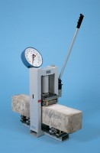 | 50 kN Mini-Flexural Machine  Code: 37-6040  Attributes: Description = 50 kN Mini-Flexural Machine  Standards:

