Determination of the Shape Index
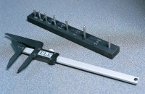 | 3.1 Shape Index Caliper.  Code: 42-0821  Attributes: Weight, kg = 1, Description = 3:1 Shape Index Calliper  Standards: EN 933-4

 | Vernier Caliper Range 0 to 200mm X 0.02mm.  Code: 81-0588  Attributes: Description = Vernier caliper, Measuring Range mm = 0 - 200 mm x 0.02 mm  Standards: EN 933-4, BS 1377

Vernier Caliper (LCD) Range 0 to 200mm X 0.01mm
Code: 81-0590
Attributes: Description = Vernier caliper, Weight, kg = 0.1, Measuring Range mm = 0 - 200 x 0.01 mm
Standards: EN 933-4

