Extension Rods, Handles and Tools
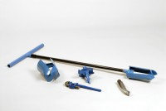 | Extension Rod 27mm Diameter 1m Long. for Use with Auger Heads  Code: 23-1541  Attributes: Description = Extension rod, Weight, kg = 1.7  Standards:

Stillson Wrench Size 14.
Code: 23-1543
Attributes: Description = Wrench, Weight, kg = 1.2
Standards:

Handle and T Piece for Use with EL23-1541.
Code: 23-1547
Attributes: Description = Handle and T piece, Weight, kg = 2
Standards:

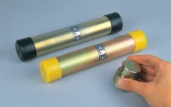 | 38mm Diameter Sample Tube 230mm Long Complete with End Caps.  Code: 23-1577  Attributes: Description = Sample tube 38 mm, Weight, kg = 0.3  Standards:

Jarring Link for Driving Sample Tubes.
Code: 23-1587
Attributes: Description = Jarring Link, Weight, kg = 4
Standards:

Spiral Auger 40mm Diameter. One Piece Model
Code: 23-1617
Attributes: Description = Spiral Auger 40 mm dia, Weight, kg = 1.5
Standards:

