Filter Paper Discs
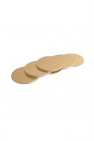 | Paper Discs  Code: 45-6462  Attributes: Description = Paper Discs, Weight, oz. = 2.9  Standards: EN 12697-30

