Modified Compaction Hammer
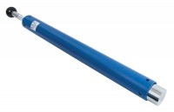 | ASTM Compaction Rammer 4.5Kg.  Code: 24-9070  Attributes: Description = ASTM/Modified Proctor rammer, Hammer Weight, lbs = 10  Standards: ASTM D1557, AASHTO T180

