Expansion Pressure Device
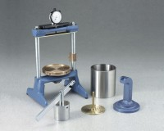 | Expansion Pressure Device  Code: 45-7580  Attributes: Mould = Hveem type; stainless steel; 4” diam. x 5” h.<br>(101.6 x 127 mm)., Description = Expansion Pressure Device  Standards: ASTM D2844, AASHTO T190, CA 301

Expansion Pressure Frame
Code: 45-7580/10
Attributes: Description = Expansion Pressure Frame
Standards:

 | Dial Indicator and Holder Assembly  Code: 45-7580/12  Attributes: Description = Dial Indicator and Holder Assembly  Standards:

Lever Type Calibration Device
Code: 45-7580/14
Attributes: Description = Lever Type Calibration Device
Standards:

R-Value Rough Hveem Test Mold
Code: 45-7505/10
Attributes: Description = R-Value Rough Hveem Test Mold
Standards:

