Direct/Residual Shear Apparatus
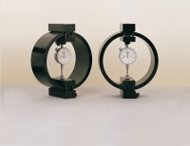 | Clamped Boss Load Ring - 4.5 kN  Code: 78-0260  Attributes: Description = Load ring - 4.5 kN, Load device type = Load ring, Force Capacity, kN = 4.5, Weight, lbs = 9.25  Standards:

Clamped Boss Load Ring - 3.0 kN
Code: 78-0160
Attributes: Description = Load ring - 3 kN, Force Capacity, kN = 3, Weight, lbs = 9.25
Standards: BS 1377, ASTM D3080

Clamped Boss Load Ring - 2.0 kN
Code: 78-0060
Attributes: Description = Load ring - 2 kN, Force Capacity, kN = 2, Value of CBR % = Up to 8%, Capacity, lbf = 450, Capacity kN = 2.0
Standards: BS 1377, ASTM D3080

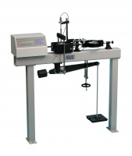 | Digital Direct/Residual Shear Apparatus Complete with Lever Loading Assembly. 110-120V 50/60Hz 1Ph.  Code: 26-2114/02  Attributes: Voltage Supply = 110-120V 50/60Hz, Description = Digital Direct/Residual Shear Apparatus, Vertical Load, lbf = 2,200  Standards: ASTM D3080, AASHTO T236

Digital Direct/Residual Shear Apparatus Complete with Lever Loading Assembly. 220-240V 50/60Hz 1Ph.
Code: 26-2114/01
Attributes: Description = Digital Direct/Residual Shear Apparatus, Voltage Supply = 220-240 V 50/60 Hz, Vertical Load, lbf = 2,200
Standards: ASTM D3080, AASHTO T236, BS 1377, EN 1997-2

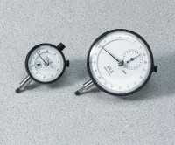 | Dial Indicator - 1.0" Range  Code: 88-4100  Attributes: Description = Mechanical Dial Indicator - 1.0" Range, Dial Indicator = 1.0" Range  Standards:

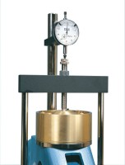 | Vertical Dial Indicator, English  Code: 25-0445  Attributes: Dial Indicator = 0.5" range x 0.0001" graduations., Description = Vertical Dial Indicator, English  Standards:

Mechanical Dial Indicator - 25 mm Range Clockwise Movement
Code: 88-4110
Attributes: Dial Indicator = 25 mm Range, Description = Mechanical Dial Indicator - 25 mm Range Clockwise Movement
Standards:

 | Electronic Digital Indicator, 0.600"/15 mm range  Code: 88-4210  Attributes: Dial Indicator = 0.6"/15 mm Range, Description = Electronic Digital Indicator, 0.600″/15 mm range  Standards:

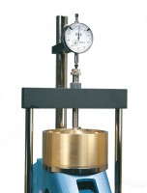 | Dial Gauge 10mm Travel X 0.002mm Divisions.  Code: 25-0440  Attributes: Description = Vertical Dial Indicator, Metric, Dial Indicator = 10 mm range x 0.002 mm<br>graduations.  Standards:

Weight Set A
Code: 25-0535
Attributes: Weight, lbs = 194.09, Description = Weight Set A
Standards:

Weight Set B
Code: 25-0537
Attributes: Weight, lbs = 70.33, Description = Weight Set B
Standards:

