NW Rock Cradle
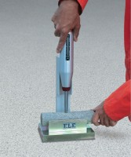 | NW Rock Cradle  Code: 77-0480  Attributes: Core Size = NW size specimens, Description = NW Rock Cradle  Standards:

