Hydrometers, Aggregate Testing
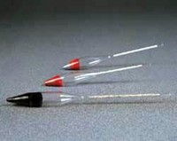 | Hydrometer  Code: 82-3505  Attributes: Description = Hydrometer used with sodium sulphate method  Standards: BS 812, EN 1367-2, ASTM C88, AASHTO T104

Hydrometer
Code: 82-3510
Attributes: Description = Hydrometer used with magnesium sulphate method
Standards: BS 812, EN 1367-2, ASTM C88, AASHTO T104

