Lightweight pH Tester
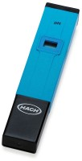 | Lightweight pH Tester  Code: 88-2010  Attributes: Environment, °F = 0°C to 50°C (32 °F to 122 °F); 95% RH., Description = Lightweight pH Tester  Standards:

