Universal Time Switches
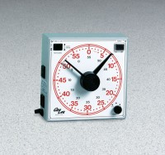 | Universal Time Switch  Code: 88-4310/02  Attributes: Controls = On/off switch; outlet switch; volume knob for buzzer., Description = Universal Time Switch  Standards:

