Cylinder Moulds
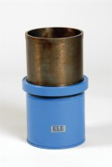 | 100mm Dia Cylinder Mould 200mm Long.  Code: 34-5210  Attributes: Specimen Size = 100 x 200 mm, Weight, kg = 16  Standards:

150mm Dia Cylinder Mould 150mm Long.
Code: 34-5230
Attributes: Specimen Size = 150 x 150 mm, Weight, kg = 14
Standards:

150mm Dia Cylinder Mould 300mm Long.
Code: 34-5260
Attributes: Specimen Size = 150 x 300 mm, Weight, kg = 12
Standards:

