Volumetric Shrinkage
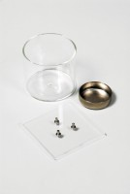 | Prong Plate.  Code: 24-1500  Attributes: Description = Prong plate, Prong Plate Dimensions sq x thickness, ” = 3 x 1/8  Standards: BS 1377, ASTM D427, AASHTO T92

Shrinkage Dish.
Code: 24-1550
Attributes: Description = Shrinkage dish, Dimensions w x d x h, ” = 32x40x14 mm
Standards: ASTM D427, AASHTO T92

Glass Cup.
Code: 24-1600
Attributes: Description = Glass cup, Weight, lbs = 0.388
Standards: ASTM D427, AASHTO T92

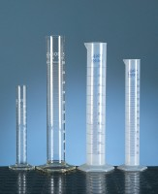 | Measuring Cylinder - Glass 100 ml  Code: 82-0380  Attributes: Description = Measuring Cylinder - Glass, Capacity, ml = 100  Standards:

 | Evaporating Dish - 150 x 45 mm  Code: 82-2000  Attributes: Diameter, mm = 150 x 45, Description = Evaporating dish  Standards:

