Accu-Tek 250 Series Block Platen Sets
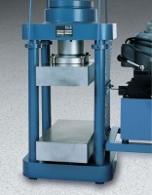 | Platen Set for 8" x 8" x 16" blocks  Code: 37-5522  Attributes: Description = Platen Set for 8″ x 8″ x 16″ blocks, Dimensions, l x w x h, ” = 8 x 16 x 6  Standards:

